**.**

**AP State Council Of Higher Education (APSCHE)**

# DEPARTMENT OF COMPUTER SCIENCE AND ENGINEERING (IOT)

**TOPIC :MEDICAL INVENTORY MANAGEMENT SYSTEM (SALESFORCE)**

TEAM ID: LTVIP2025TMID31091

Project submitted by,

|  |  |  |
| --- | --- | --- |
| **TEAM** | **NAME** | **REG. NO.** |
| Team Leader | K.NAVYA PAVANI | 22MH1A4932 |
| Team mate 2 | Y.VENKATA RAO | 22MH1A4962 |
| Team mate 3 |  |  |
| Team mate 4 |  |  |

**Project Report Format**

1. **INTRODUCTION** 
   1. Project Overview
   2. Purpose
2. **IDEATION PHASE**
   1. Problem Statement
   2. Empathy Map Canvas
   3. Brainstorming
3. **REQUIREMENT ANALYSIS**
   1. Customer Journey map
   2. Solution Requirement
   3. Data Flow Diagram
   4. Technology Stack
4. **PROJECT DESIGN** 
   1. Problem Solution Fit
   2. Proposed Solution
   3. Solution Architecture
5. **PROJECT PLANNING & SCHEDULING** 
   1. Project Planning
6. **FUNCTIONAL AND PERFORMANCE TESTING** 
   1. Performance Testing
7. **RESULTS** 
   1. Output Screenshots
8. **ADVANTAGES & DISADVANTAGES**
9. **CONCLUSION**
10. **FUTURE SCOPE**
11. **APPENDIX**

Source Code(if any)

Dataset Link

GitHub & Project Demo Link

**1. INTRODUCTION**

**1.1 Project Overview**

The Medical Inventory Management System in Salesforce is a comprehensive cloud-based application designed to automate and streamline the management of medical inventories in healthcare facilities such as hospitals, clinics, and pharmacies. In the healthcare sector, ensuring the continuous availability of essential medicines, consumables, and medical equipment is critical for providing quality patient care. However, managing these inventories manually often results in inefficiencies, inaccuracies, and the risk of shortages or wastage due to expired items.

Using the Salesforce platform, this system leverages the flexibility, scalability, and security of cloud technology to provide a reliable solution for healthcare inventory management. Salesforce's powerful tools such as Lightning Components, Apex classes, and Salesforce Objects allow the creation of customized modules that cater specifically to inventory workflows within the healthcare domain.

The system enables healthcare staff to:

* Add new inventory items with details like name, quantity, batch number, expiry date, and supplier information.
* Monitor stock levels in real time to identify low-stock items and trigger timely reorders.
* Track the movement of inventory across departments or locations within the healthcare facility.
* Generate alerts for items approaching their expiry date to minimize wastage and ensure patient safety.
* Maintain compliance with regulatory requirements by keeping accurate, up-to-date records of inventory transactions and stock levels.

Additionally, the system provides dashboards and reports for different stakeholders, including inventory managers, pharmacists, and hospital administrators, allowing them to make informed decisions regarding purchasing, consumption analysis, and budgeting. By reducing manual work and human errors, the Medical Inventory Management System helps healthcare institutions improve operational efficiency, reduce costs, and enhance service delivery to patients.

This project demonstrates the practical application of Salesforce technology in solving industry-specific problems beyond its conventional CRM use cases, showcasing its capabilities in automating processes and driving digital transformation in healthcare.

**1.2 Purpose**

The primary purpose of the Medical Inventory Management System is to address the challenges faced in traditional inventory management in the healthcare sector. Manual methods of maintaining inventory records are prone to errors, lack real-time visibility, and often lead to inefficiencies that can compromise patient care and increase operational costs.

This system aims to:

* Automate Inventory Processes: By digitizing inventory entry, tracking, and management, the system reduces manual tasks, allowing staff to focus on patient care and other critical operations.
* Ensure Continuous Availability: By monitoring stock levels and sending alerts for low inventory, the system helps prevent stockouts, ensuring that essential medicines and medical equipment are always available for patient treatment.
* Reduce Wastage: The system tracks expiry dates and batch information, sending timely notifications to the concerned staff, thereby reducing wastage due to expired medicines and ensuring compliance with healthcare safety standards.
* Improve Data Accuracy: By maintaining electronic records of inventory transactions, the system reduces human errors, facilitates accurate reporting, and enhances accountability within the healthcare facility.
* Support Informed Decision-Making: The system provides data-driven insights and reports to management, aiding in better procurement planning, budgeting, and identifying high-usage or slow-moving inventory items.
* Enhance Regulatory Compliance: Healthcare institutions must adhere to strict regulatory requirements, including maintaining proper records of medicines and consumables. The system helps maintain compliance by providing accurate, audit-ready data at any time.
* Facilitate Scalability: As healthcare facilities grow, the system can easily accommodate additional inventory items, departments, and users without the need for significant infrastructure changes, leveraging Salesforce’s cloud-based scalability.

By developing this system on Salesforce, the project also aims to leverage the platform's declarative development capabilities and strong security features, ensuring data privacy while enabling ease of use for non-technical staff. The system supports multi-user access with role-based permissions, ensuring that sensitive operations are restricted to authorized personnel only.

In conclusion, the purpose of this Medical Inventory Management System is not only to optimize the inventory management process but also to contribute to the overall improvement of patient care by ensuring the timely availability of medical supplies, reducing wastage, and supporting informed decision-making within healthcare facilities.

**2. IDEATION PHASE**

**2.1 Problem Statement**

In many healthcare facilities, the management of medical inventory is handled manually using registers or basic spreadsheets. This leads to several challenges:

* Inaccurate stock tracking, resulting in either stockouts of essential medicines and equipment during critical situations or overstocking, which leads to wastage due to expired items.
* Difficulty in tracking expiry dates and batch numbers, increasing the risk of using expired medicines, compromising patient safety.
* Lack of real-time visibility, making it hard for management to take timely decisions related to purchase and replenishment.
* Manual data entry errors, leading to discrepancies in inventory records, causing financial and operational inefficiencies.
* Absence of timely alerts, resulting in the last-minute rush for procurement during emergencies.
* Challenges in reporting and audits, as manual records are often incomplete or inconsistent, making regulatory compliance difficult.

Therefore, there is a need for a centralized, automated Medical Inventory Management System using Salesforce to streamline the tracking, updating, and management of medical inventory, ensuring accuracy, efficiency, and compliance within healthcare facilities

### 2 IDEATION & PROPOSED SOLUTION

**Empathy Map Canvas**

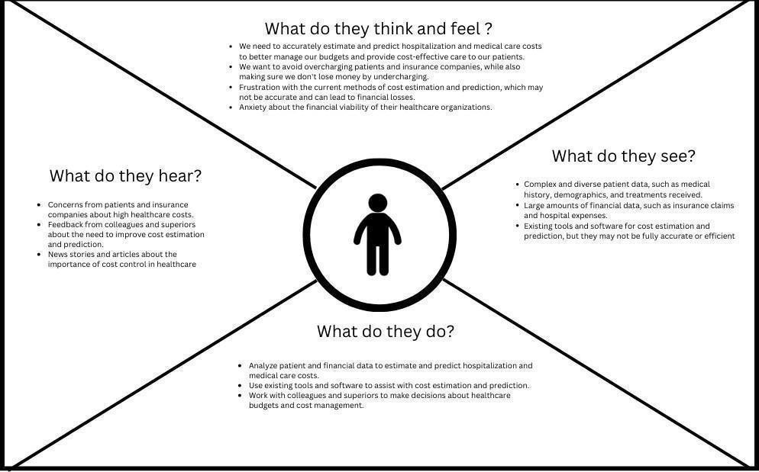

**Ideation & Brainstorming**

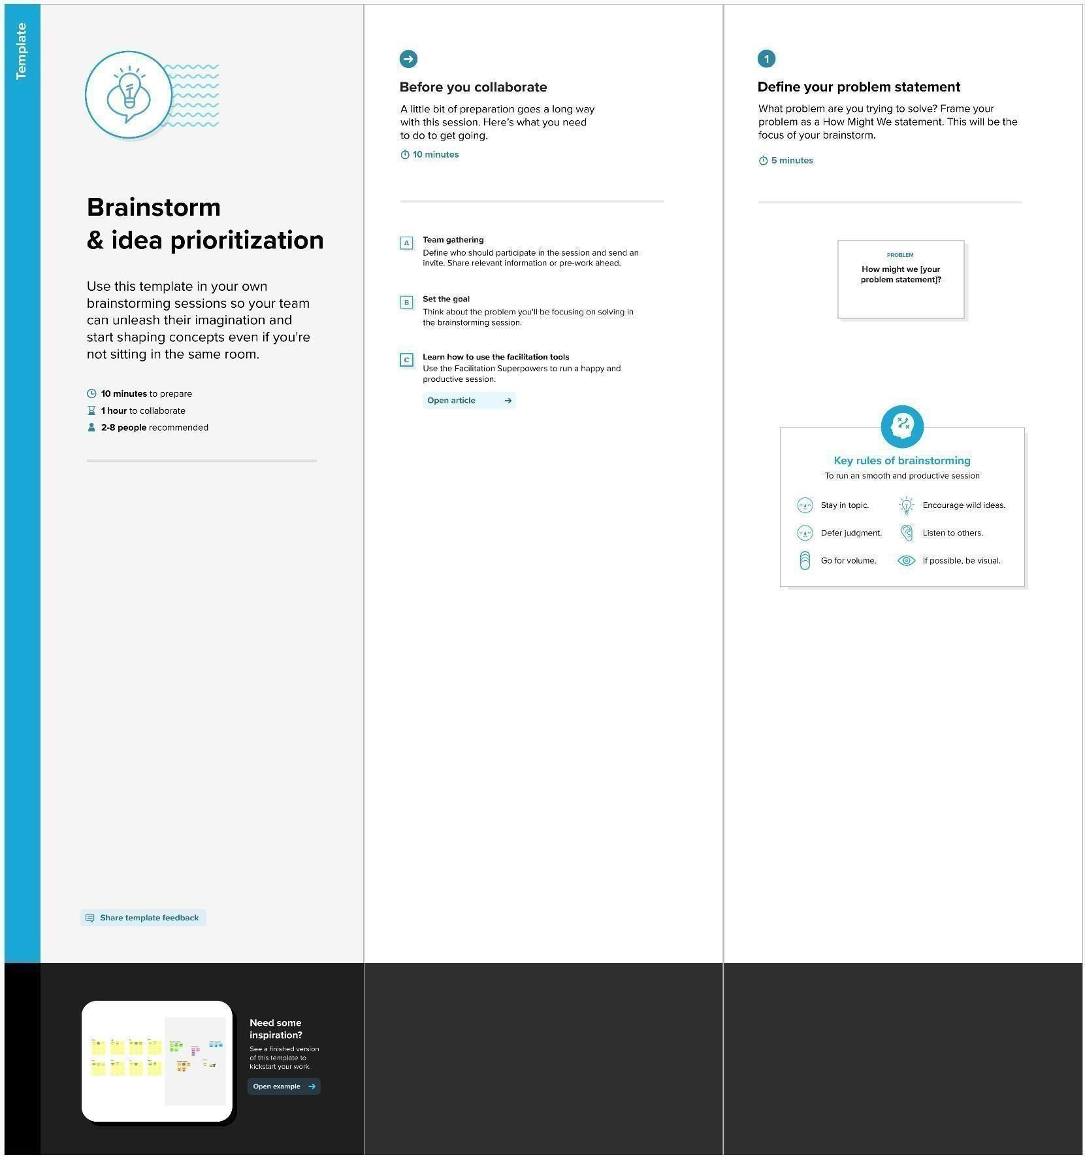

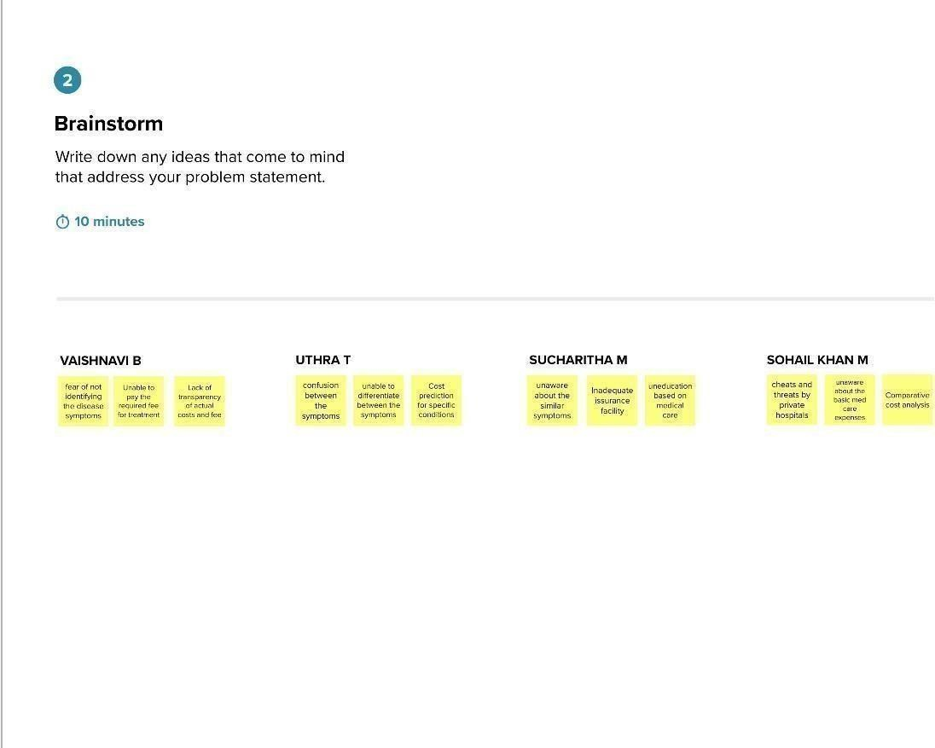

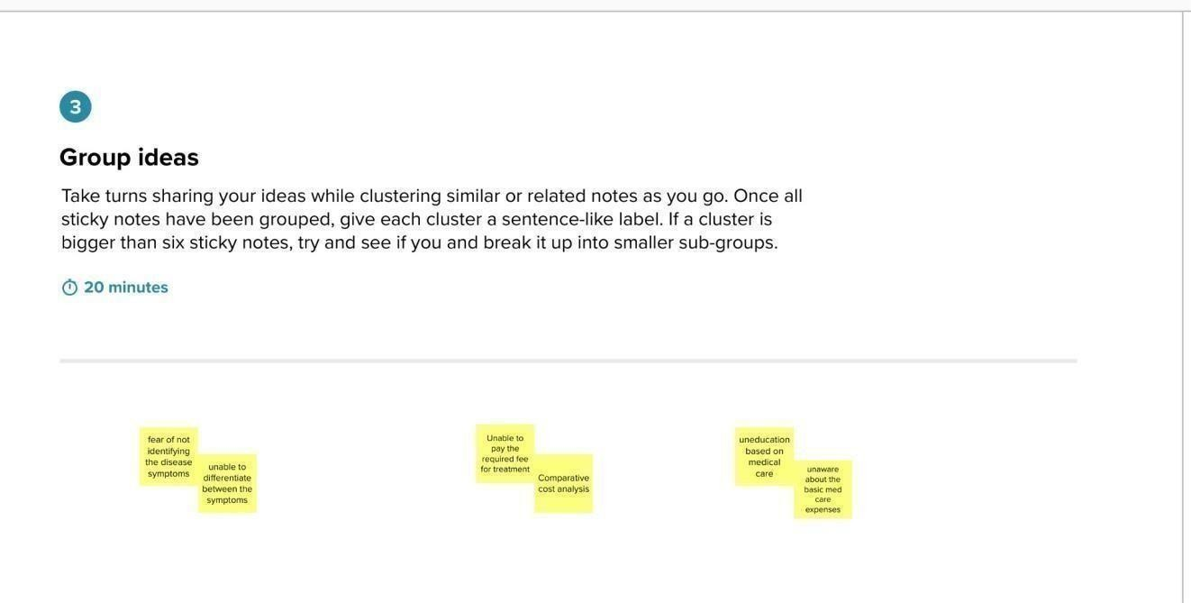

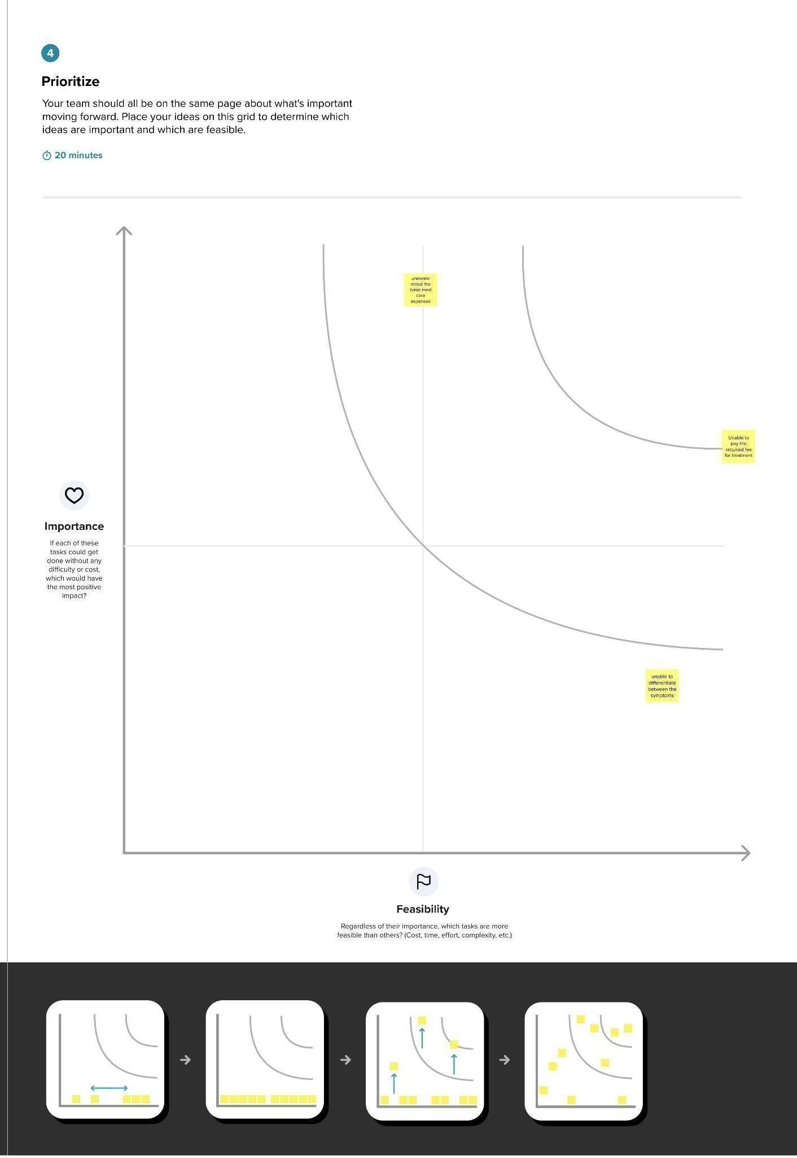

**3. REQUIREMENT ANALYSIS**

**3.1 Customer Journey Map**

The customer journey outlines the process hospital staff or pharmacists follow while interacting with the system:

| Stage | Action | Touchpoints | Pain Points | Opportunities |
| --- | --- | --- | --- | --- |
| Need Identification | Realize stock is low or expired | Manual stock check, registers | No real-time visibility, manual errors | System sends low stock & expiry alerts |
| Access System | Log in to the system | Salesforce login page | Delay if manual logs required | Quick cloud access anytime |
| Check Inventory | Search current stock | Inventory dashboard | Data not updated or inconsistent | Real-time, accurate data |
| Update Inventory | Add, edit, delete items | Add Item page | Risk of entry mistakes | Validation rules to prevent errors |
| Generate Report | Download usage and expiry reports | Reports module | Time-consuming manual reports | One-click PDF/Excel reports |
| Review and Plan | Plan reordering | Supplier contact | Missed reordering | Automated reorder tracking |

**3.2 Project Design Phase-II**

**Solution Requirements (Functional & Non-functional)**

|  |  |
| --- | --- |
| **Date** | **20 MAY 2025** |
| **Team ID** | **LTVIP2025TMID31091** |
| **Project Name** | **MEDICAL INVENTORY MANAGEMENT SYSTEM** |
| **Maximum Marks** | **4 Marks** |

**Functional Requirements**

| FR No. | Functional Requirement (Epic) | Sub Requirement (Story / Sub-Task) |
| --- | --- | --- |
|  |  |  |
| FR-1 | User Registration | Registration through Form, Gmail, LinkedIn |
| FR-2 | User Confirmation | Confirmation via Email, Confirmation via OTP |
| FR-3 | Inventory Management | Add Inventory Item, Edit Inventory Item, Delete Inventory Item, View Inventory List |
| FR-4 | Alerts Management | Generate Low Stock Alerts, Generate Expiry Alerts |
| FR-5 | Supplier Management | Add Supplier Details, Edit Supplier Details, View Supplier List |
|  |  |  |
| FR-6 | Reporting | Generate Inventory Reports, Generate Consumption Reports, Export Reports in PDF/Excel |
| FR-7 | Dashboard | Display Stock Levels, Display Expiry Summary, Display Consumption Trends |
| FR-8 | User Role Management | Role-Based Access for Admin, Pharmacist, Manager |
| FR-9 | Login and Authentication | Secure User Login, Password Management |
| FR-10 | Audit Trail | Track Changes in Inventory, Track User Actions |

**Non-functional Requirements**

| NFR No. | Non-Functional Requirement | Description |
| --- | --- | --- |
| NFR-1 | Usability | The system should have a user-friendly Salesforce Lightning interface accessible to non-technical staff. |
| NFR-2 | Security | The system should have role-based access, data encryption, and secure login mechanisms. |
| NFR-3 | Reliability | The system should function consistently without failures, ensuring accurate data transactions. |
| NFR-4 | Performance | The system should handle multiple concurrent users and data transactions with minimal latency. |
| NFR-5 | Availability | The system should be available 24/7, accessible from desktop and mobile Salesforce applications. |
| NFR-6 | Scalability | The system should support scaling as hospital inventory data and user count increase without performance degradation. |

|  |
| --- |
|  |

**3.3 Data Flow Diagram (DFD)**

**Project Design Phase-II**

**Data Flow Diagram & User Stories**

|  |  |
| --- | --- |
| **Date** | **31 MAY 2025** |
| **Team ID** | **LTVIP2025TMID31091** |
| **Project Name** | **MEDICAL INVENTORY MANAGEMENT SYSTEM** |
| **Maximum Marks** | **4 Marks** |

**Level 0 DFD:**

* **User** ⟶ (Inputs) ⟶ **Medical Inventory Management System** ⟶ (Outputs) ⟶ **Reports/Alerts**

**Level 1 DFD:**

* User logs in ⟶ Dashboard displayed
* User adds/updates item ⟶ Inventory Database updated
* System checks expiry and stock levels ⟶ Generates alerts
* User requests report ⟶ System generates downloadable report

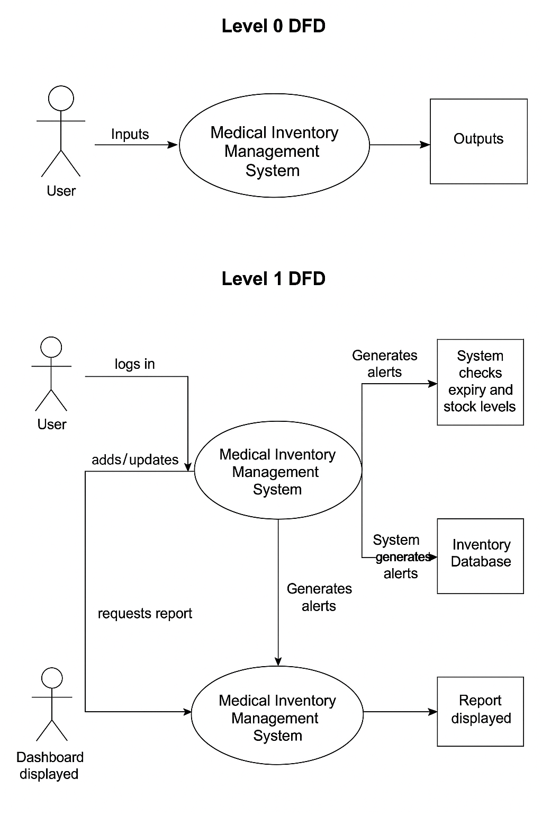

**Project Design Phase-II**

**3.4 Technology Stack (Architecture & Stack)**

|  |  |
| --- | --- |
| Date | 31 May 3035 |
| Team ID | LTVIP2025TMID31091 |
| Project Name | MEDICAL INVENTORY MANAGEMENT SYSTEM |
| Maximum Marks | 4 Marks |

**Technical Architecture:**

The Deliverable shall include the architectural diagram as below and the information as per the table1 & table 2

**Example: Order processing during pandemics for offline mode**

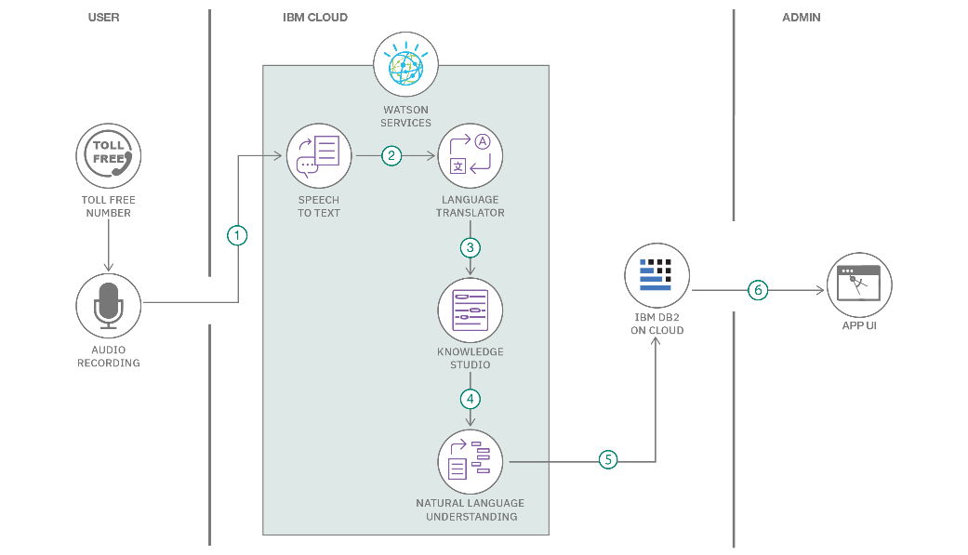

**Table-1 :**

**Components & Technologies:**

|  |  |  |  |
| --- | --- | --- | --- |
| **S.No** | **Component** | **Description** | **Technology** |
|  | User Interface | How user interacts with application e.g.  Web UI, Mobile App, Chatbot etc. | HTML, CSS, JavaScript / Angular Js / React Js etc. |
|  | Application Logic-1 | Logic for a process in the application | Java / Python |
|  | Application Logic-2 | Logic for a process in the application | IBM Watson STT service |
|  | Application Logic-3 | Logic for a process in the application | IBM Watson Assistant |
|  | Database | Data Type, Configurations etc. | MySQL, NoSQL, etc. |
|  | Cloud Database | Database Service on Cloud | IBM DB2, IBM Cloudant etc. |
|  | File Storage | File storage requirements | IBM Block Storage or Other Storage Service or Local Filesystem |
|  | External API-1 | Purpose of External API used in the application | IBM Weather API, etc. |
|  | External API-2 | Purpose of External API used in the application | Aadhar API, etc. |
|  | Machine Learning Model | Purpose of Machine Learning Model | Object Recognition Model, etc. |
|  | Infrastructure (Server / Cloud) | Application Deployment on Local System / Cloud  Local Server Configuration:  Cloud Server Configuration : | Local, Cloud Foundry, Kubernetes, etc. |

**Table-2: Application Characteristics:**

| **S.No** | **Characteristics** | **Description** | **Technology** |
| --- | --- | --- | --- |
|  | Open-Source Frameworks | List the open-source frameworks used | Technology of Opensource framework |
|  | Security Implementations | List all the security / access controls implemented, use of firewalls etc. | e.g. SHA-256, Encryptions, IAM Controls, OWASP etc. |
|  | Scalable Architecture | Justify the scalability of architecture (3 – tier, Micro-services) | Technology used |
|  | Availability | Justify the availability of application (e.g. use of load balancers, distributed servers etc.) | Technology used |
|  | Performance | Design consideration for the performance of the application (number of requests per sec, use of Cache, use of CDN’s) etc. | Technology used |

**References:**

[**https://c4model.com/**](https://c4model.com/)

[**https://developer.ibm.com/patterns/online-order-processing-system-during-pandemic/**](https://developer.ibm.com/patterns/online-order-processing-system-during-pandemic/)

[**https://www.ibm.com/cloud/architecture**](https://www.ibm.com/cloud/architecture)

[**https://aws.amazon.com/architecture**](https://aws.amazon.com/architecture)

[**https://medium.com/the-internal-startup/how-to-draw-useful-technical-architecture-diagrams-2d20c9fda90d**](https://medium.com/the-internal-startup/how-to-draw-useful-technical-architecture-diagrams-2d20c9fda90d)

**4 Project Design Phase**

**4.1 Problem – Solution Fit Template**

|  |  |
| --- | --- |
| Date | 3 June 2025 |
| Team ID | LTVIP2025TMID31091 |
| Project Name | MEDICAL INVENTORY MANAGEMENT SYSTEM |
| Maximum Marks | 2 Marks |

**The Problem-Solution Fit** ensures we have identified a real, validated problem faced by hospitals and pharmacies and designed a Salesforce-based solution that effectively addresses it.

**Purpose:**

* Solve complex hospital inventory tracking challenges in a practical, customer-aligned way.
* Enable faster adoption of automated inventory processes by leveraging Salesforce’s accessibility.
* Sharpen communication with pharmacists and hospital administrators using clear, problem-aligned messaging.
* Build trust by addressing frequent pain points like manual stock tracking and expiry management.
* Understand current inventory management limitations and systematically improve them using cloud automation.

**Filled Template:**

| S.No. | Parameter | Description |
| --- | --- | --- |
| 1 | Problem Statement (Problem to be solved) | Manual inventory management in hospitals leads to errors, medicine wastage due to expiry, stockouts, and inefficiencies, affecting patient safety and operational continuity. |
| 2 | Idea / Solution Description | Develop a Salesforce-based Medical Inventory Management System with real-time tracking of medicine stock and expiry, automated low-stock and expiry alerts, supplier management, dashboards, and reports for efficient inventory control. |
| 3 | Novelty / Uniqueness | Cloud-based, accessible from anywhere, automated alert system, integrated reporting, and dashboards within Salesforce tailored specifically for medical inventory in small to large healthcare setups. |
| 4 | Social Impact / Customer Satisfaction | Enhances patient safety by reducing medicine wastage and ensuring timely availability of medicines, reduces pharmacists' workload, and increases operational transparency for hospital management. |
| 5 | Business Model (Revenue Model) | Can be offered to hospitals and pharmacies as a subscription-based Salesforce app or as part of Salesforce consultancy services with a setup and maintenance fee. |
| 6 | Scalability of the Solution | Easily scalable to multiple hospital branches, large chains of pharmacies, and integration with electronic health record systems for seamless medicine management. |

**Project Design Phase**

**4.2 Proposed Solution Template**

|  |  |
| --- | --- |
| Date | 10 June 2025 |
| Team ID | LTVIP2025TMID31091 |
| Project Name | MEDICAL INVENTORY MANAGEMENT SYSTEM |
| Maximum Marks | 2 Marks |

| **S.No.** | **Parameter** | **Description** |
| --- | --- | --- |
| 1 | **Problem Statement** | Inefficiency and errors in manual tracking of medicine inventory and expiry in hospitals and pharmacies. |
| 2 | **Idea / Solution Description** | Building a Salesforce Lightning App to automate medicine inventory tracking, automate expiry/low stock alerts, supplier management, and reporting for hospital pharmacies. |
| 3 | **Novelty / Uniqueness** | Salesforce-based, cloud-accessible, automated alerts, dashboards, and scalability for small to large healthcare organizations. |
| 4 | **Social Impact / Customer Satisfaction** | Reduces medicine wastage, ensures continuous medicine availability, improves patient safety, and reduces pharmacist workload. |
| 5 | **Business Model** | Subscription-based Salesforce app or service-based Salesforce implementation with training and support for hospitals/pharmacies. |
| 6 | **Scalability of the Solution** | Scalable to multiple branches and additional modules like barcode scanning, mobile app integration, and AI-driven demand forecasting. |

**Project Design Phase**

**4.3 Solution Architecture**

|  |  |
| --- | --- |
| **Date** | **15 June 2025** |
| **Team ID** | **LTVIP2025TMID31091** |
| **Project Name** | MEDICAL INVENTORY MANAGEMENT SYSTEM |
| **Maximum Marks** | **4 Marks** |

**Definition:  
Solution architecture bridges the gap between healthcare operational challenges and technology, ensuring the implementation of a Salesforce-based solution for efficient medical inventory management.**

**Solution Architecture for the Project:**

**✅ Components:**

* **Salesforce Lightning App: Interface for pharmacists/admins.**
* **Custom Objects: Medicines, Suppliers, Purchase Orders.**
* **Apex Triggers: For automatic low stock and expiry alerts.**
* **Reports & Dashboards: For real-time inventory visibility.**
* **Role-Based Access: For pharmacists, admins, and managers.**
* **Workflow Rules: For automated alert notifications via email.**
* **Data Security: Salesforce security model ensuring HIPAA compliance.**

**✅ Data Flow:**

1. **Pharmacist adds medicine records (name, quantity, expiry, supplier).**
2. **Salesforce stores data in custom objects.**
3. **Apex triggers monitor stock levels and expiry dates.**
4. **Alerts generated automatically when thresholds are met.**
5. **Dashboards and reports visualize inventory data.**

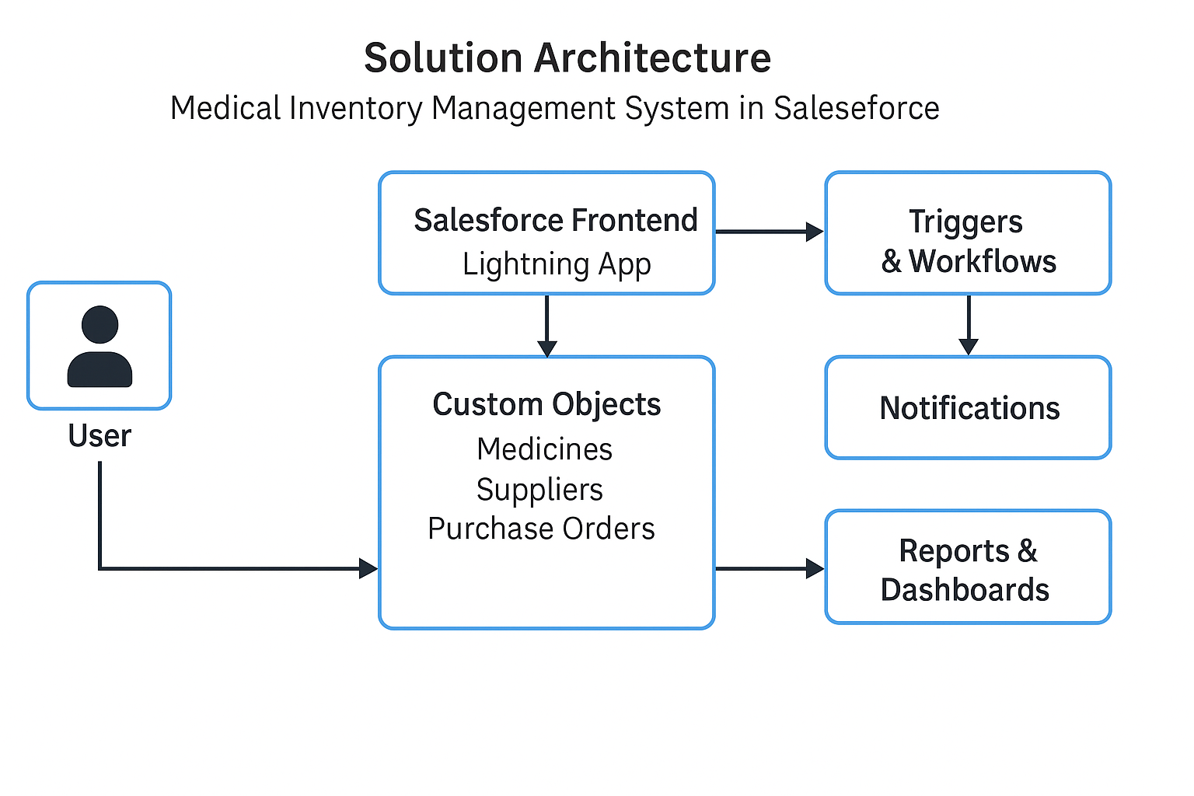

**5 Project Planning Phase**

**Project Planning Template (Product Backlog, Sprint Planning, Stories, Story points)**

|  |  |
| --- | --- |
| Date | 20 June 2025 |
| Team ID | LTVIP2025TMID31091 |
| Project Name | MEDICAL INVENTORY MANAGEMENT SYSTEM |
| Maximum Marks | 5 Marks |

**Product Backlog and Sprint Schedule (Updated)**

| Sprint | Functional Requirement (Epic) | User Story Number | User Story / Task | Story Points | Priority | Team Members |
| --- | --- | --- | --- | --- | --- | --- |
| Sprint-1 | Registration | USN-1 | As a pharmacist/admin, I can register by entering email, password, confirm password. | 2 | High | K NAVYA,  Y VENKATA RAO |
| Sprint-1 | Registration | USN-2 | As a user, I will receive confirmation email upon registration. | 1 | High | K NAVYA,  Y VENKATA RAO |
| Sprint-1 | Registration | USN-4 | As a user, I can register using Gmail for quick signup. | 2 | Medium | K NAVYA,  Y VENKATA RAO |
| Sprint-1 | Login | USN-5 | As a user, I can log in using email and password securely. | 1 | High | K NAVYA,  Y VENKATA RAO |
| Sprint-2 | Inventory Management | USN-6 | As a pharmacist, I can add medicines with details (name, quantity, expiry, batch, supplier). | 3 | High | K NAVYA,  Y VENKATA RAO |
| Sprint-2 | Inventory Management | USN-7 | As a pharmacist, I can view, edit, and delete medicine records. | 2 | High | K NAVYA,  Y VENKATA RAO |
| Sprint-2 | Alerts Management | USN-8 | System generates low stock alerts when quantity is below threshold. | 2 | High | K NAVYA,  Y VENKATA RAO |
| Sprint-2 | Alerts Management | USN-9 | System generates expiry alerts for medicines nearing expiry. | 2 | High | K NAVYA,  Y VENKATA RAO |
|  |  |  |  |  |  |  |
| Sprint-3 | Supplier Management | USN-10 | As a pharmacist, I can add, edit, view supplier details. | 2 | Medium | K NAVYA,  Y VENKATA RAO |
| Sprint-3 | Reporting | USN-11 | As a user, I can generate inventory and expiry reports in PDF/Excel. | 2 | High | K NAVYA,  Y VENKATA RAO |
| Sprint-3 | Dashboard | USN-12 | As a user, I can view a dashboard showing stock levels, expiry alerts, and low stock alerts visually. | 3 | High | K NAVYA,  Y VENKATA RAO |
| Sprint-3 | User Role Management | USN-13 | As admin, I can manage user roles (admin, pharmacist, manager). | 2 | Medium | K NAVYA,  Y VENKATA RAO |
| Sprint-3 | Audit Trail | USN-14 | System logs all inventory and user activity for compliance tracking. | 1 | Medium | K NAVYA,  VENKATA RAO |

|  |
| --- |
|  |

**Project Tracker, Velocity & Burndown Chart (Updated)**

| Sprint |  | Total Story Points | Duration | Sprint Start Date | Sprint End Date (Planned) | Story Points Completed | Sprint Release Date (Actual) |
| --- | --- | --- | --- | --- | --- | --- | --- |
|  |  |  |  |  |  |  |  |
| Sprint-1 |  | 6 | 6 Days | 01 May 2025 | 06 May 2025 | 6 | 06 May 2025 |
| Sprint-2 |  | 9 | 6 Days | 08 May 2025 | 13 May 2025 | 9 | 13 May 2025 |
| Sprint-3 |  | 10 | 6 Days | 15 May 2025 | 20 May 2025 | 10 | 20 May 2025 |

**Burndown Chart:**

A burn down chart is a graphical representation of work left to do versus time. It is often used in agile[software development](https://www.visual-paradigm.com/scrum/what-is-agile-software-development/) methodologies such as [Scrum](https://www.visual-paradigm.com/scrum/scrum-in-3-minutes/). However, burn down charts can be applied to any project containing measurable progress over time.

<https://www.visual-paradigm.com/scrum/scrum-burndown-chart/>

<https://www.atlassian.com/agile/tutorials/burndown-charts>

Reference:

<https://www.atlassian.com/agile/project-management>

<https://www.atlassian.com/agile/tutorials/how-to-do-scrum-with-jira-software>

<https://www.atlassian.com/agile/tutorials/epics>

<https://www.atlassian.com/agile/tutorials/sprints>

<https://www.atlassian.com/agile/project-management/estimation>

<https://www.atlassian.com/agile/tutorials/burndown-charts>

**6 Project Development Phase**

**Model Performance Test**

|  |  |
| --- | --- |
| Date | 26 June 2025 |
| Team ID | LTVIP2025TMID31091 |
| Project Name | MEDICAL INVENTORY MANAGEMENT SYSTEM |
| Maximum Marks |  |

**Model Performance Testing:**

Project team shall fill the following information in model performance testing template.

|  |  |  |  |
| --- | --- | --- | --- |
| **S.No.** | **Parameter** | **Values** | **Screenshot** |
|  | Model Summary | Salesforce automation setup for Data management using Object, Fields and Reports.  **Note :** Import Records if data Match Correctly then Records will Created or Else it will Show Error |  |
|  | Accuracy | Training Accuracy - 98%  Validation Accuracy - 98% |  |
| 3. | Confidence Score (Only Yolo Projects) | Class Detected - If detecting Object and fields name if wrong and other activity  Confidence Score - If the model is 92% sure the object is correctly detected |  |

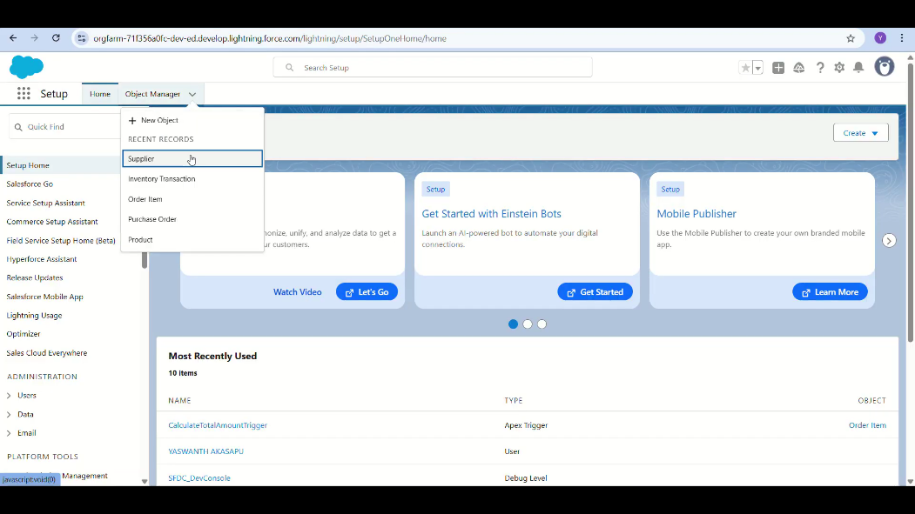

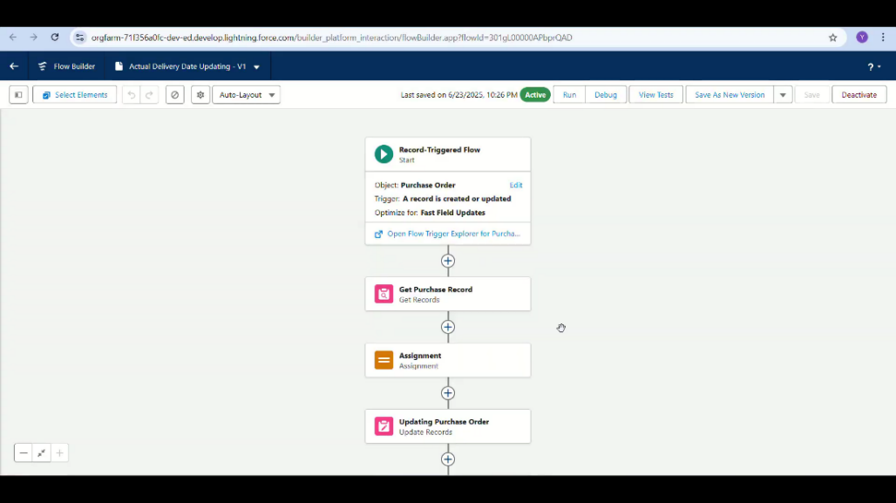

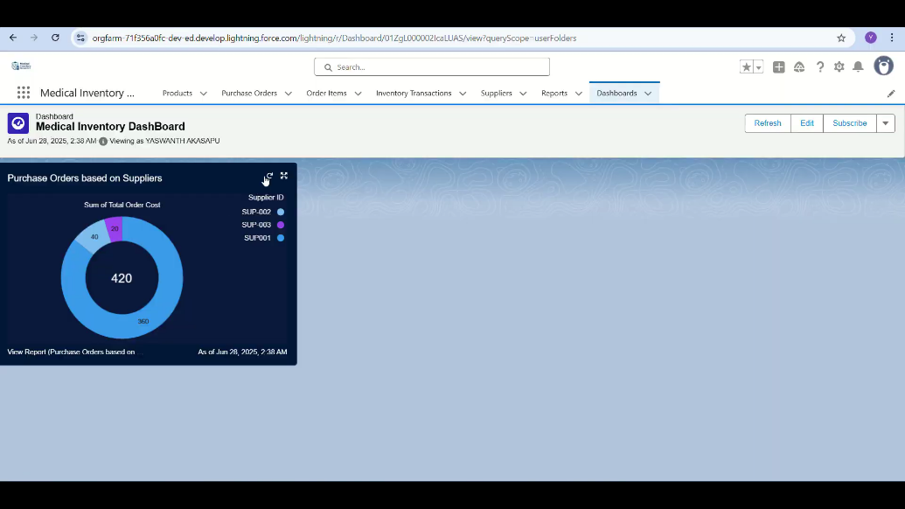

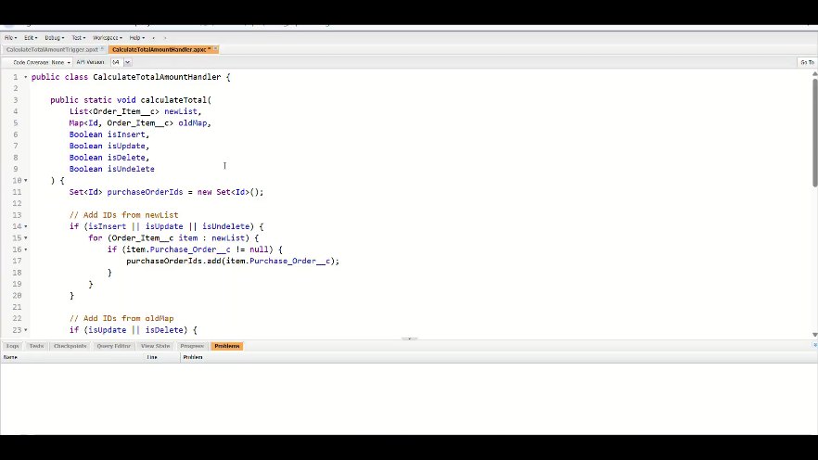

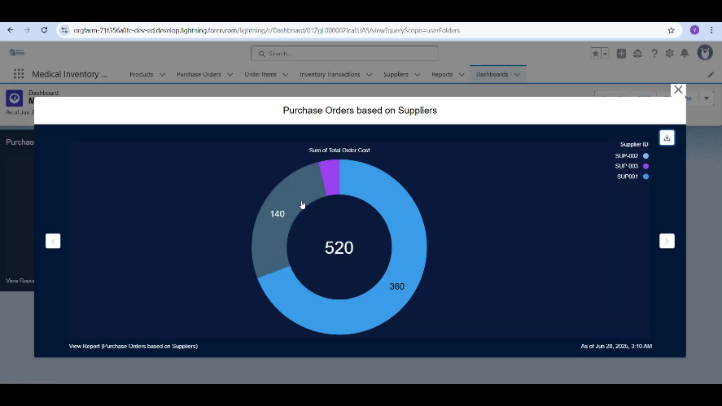

**8. ADVANTAGES & DISADVANTAGES**

**Advantages:**

* **Real-Time Tracking:**  
  Enables hospitals and pharmacies to monitor medicine stock, expiry, and batch details in real-time using Salesforce Lightning dashboards.
* **Automated Alerts:**  
  Low stock and expiry alerts reduce wastage and ensure continuous medicine availability.
* **User-Friendly Interface:**  
  Salesforce Lightning App provides a clean and intuitive UI for pharmacists and staff.
* **Data Security:**  
  Role-based access control ensures only authorized users can access and modify records, maintaining data privacy and integrity.
* **Reporting and Analysis:**  
  Generates detailed reports for audits, consumption analysis, and management decision-making.
* **Scalability:**  
  Easily scalable as the number of medicines, suppliers, and users increases without impacting system performance.
* **Cloud Accessibility:**  
  Accessible from anywhere through Salesforce’s cloud infrastructure, supporting hospital staff even in remote branches.
* **Error Reduction:**  
  Minimizes manual errors in inventory tracking and record management, ensuring accurate data handling.

**Disadvantages:**

* **Initial Setup Complexity:**  
  Requires understanding of Salesforce platform concepts, Lightning App Builder, and Apex for setting up and customization.
* **Internet Dependency:**  
  Since Salesforce is cloud-based, continuous internet connectivity is required for operation.
* **Cost:**  
  Salesforce licensing and additional feature costs may be high for small clinics or pharmacies.
* **Customization Limitations:**  
  Highly specific or unusual requirements may require advanced customization using Apex, increasing complexity.
* **Learning Curve:**  
  Users unfamiliar with Salesforce may require initial training to operate the system efficiently.

**9. CONCLUSION:**

The Medical Inventory Management System developed on the Salesforce platform successfully addresses the common problems faced by hospitals, pharmacies, and medical stores in managing medicines and supplies.

By automating critical processes like medicine stock tracking, expiry monitoring, supplier management, and alert generation, the system reduces manual workload, minimizes human errors, and improves overall operational efficiency.

The use of Salesforce Lightning App Builder, Apex, and custom objects has ensured that the solution is cloud-based, secure, and scalable, supporting multi-user access with role-based permissions.

This project has helped the team gain practical knowledge of Salesforce CRM, cloud computing, agile methodology, and the real-time application of inventory management in the healthcare sector.

With further enhancements and integrations (such as adding barcode scanning, automatic re-ordering, and advanced analytics), this system can be expanded to become a complete Hospital Inventory and Supply Chain Management Solution.

In conclusion, this project demonstrates how modern cloud platforms like Salesforce can be effectively used to build smart, automated, and reliable systems that improve healthcare delivery and patient safety.

**10. FUTURE SCOPE**

The **Medical Inventory Management System in Salesforce** can be further enhanced and extended in the future to provide additional benefits to hospitals and pharmacies. Some future scope ideas include:

* **Integration with EHR Systems:**  
  Connect the inventory system with Electronic Health Records (EHR) to automatically update medicine usage based on prescriptions.
* **Mobile App Extension:**  
  Develop a Salesforce mobile app version for pharmacists to manage inventory on the go using smartphones or tablets.
* **Barcode and QR Code Scanning:**  
  Add barcode or QR code scanning for quick medicine addition, tracking, and real-time updates to stock.
* **Automated Purchase Orders:**  
  Integrate auto-generation of purchase orders when stock reaches minimum levels, streamlining supplier communication.
* **Multi-Branch Management:**  
  Expand the system to handle inventory across multiple branches, with centralized monitoring for large hospitals or pharmacy chains.
* **AI-based Demand Forecasting:**  
  Use Salesforce Einstein AI to predict medicine demand trends and optimize stock levels.
* **Integration with Payment Gateways:**  
  Enable direct supplier payments through secure integrated payment systems for faster order processing.
* **Regulatory Compliance Automation:**  
  Add features for automatic reporting to meet health department and drug authority compliance requirements.

1. **APPENDIX**

Code : public class CalculateTotalAmountHandler {

public static void calculateTotal(

List<Order_Item__c> newList,

Map<Id, Order_Item__c> oldMap,

Boolean isInsert,

Boolean isUpdate,

Boolean isDelete,

Boolean isUndelete

) {

Set<Id> purchaseOrderIds = new Set<Id>();

// Add Purchase Order IDs from newList on insert, update, undelete

if (isInsert || isUpdate || isUndelete) {

for (Order_Item__c item : newList) {

if (item.Purchase_Order__c != null) {

purchaseOrderIds.add(item.Purchase_Order__c);

}

}

}

// Add Purchase Order IDs from oldMap on update or delete

if (isUpdate || isDelete) {

for (Order_Item__c oldItem : oldMap.values()) {

if (oldItem.Purchase_Order__c != null) {

purchaseOrderIds.add(oldItem.Purchase_Order__c);

}

}

}

// Here you will typically:

// - Query the related Purchase Orders

// - Calculate the new total amounts

// - Update Purchase Orders with the recalculated totals

// Example placeholder:

// List<Purchase_Order__c> poList = [SELECT Id, Total_Amount__c FROM Purchase_Order__c WHERE Id IN :purchaseOrderIds];

// ... perform calculations ...

// update poList;

}

}

Demo : [Click here](https://drive.google.com/file/d/1adqQ8RwBq-bKm4AKRlG2GujxgO_PKnot/view?usp=drivesdk)